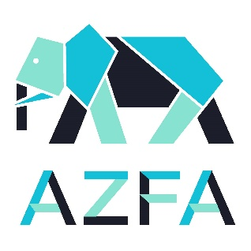
2021 Virtual Conference Series
CATALYST FOR GOOD CHANGE
Session 2 Agenda
March 25th

Host: Florence Tang – Project Manager, Design & Engineering, Houston Zoo

- Welcome and Introduction

- News Roundup
Allmon Forrester – Director of Facilities, Planning & Sustainability, John Ball Zoo

- AZFA Member of the Month
Nikki Myers – Director of Facilities Operations & Maintenance, Denver Zoo

- Feature Presentation: Building Ocean Wonders: Sharks!
Sue Chin – VP of Planning & Design and Chief Architect, WCS/New York Aquarium

- Featured Facility: Woodland Park Zoo
John Borgmeyer, Exhibit Manager

- Sponsor Spotlight: COST of Wisconsin

- Prize Raffle

- Next Session: April 22, 2021 at 2:00 p.m. CST
Feature Presentation – Partnering with Tomorrow’s Leaders for a More Sustainable
Future: A Case Study with Duckweed by John Kanzia, Brookfield Zoo

