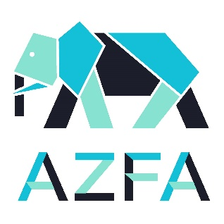
2021 Virtual Conference Series
CATALYST FOR GOOD CHANGE
Session 3 Agenda
April 22nd

Host: John Kanzia – Environmental Quality Manager, Brookfield Zoo

- Welcome and Introduction

- News Roundup
Allmon Forrester – Director of Facilities, Planning & Sustainability, John Ball Zoo

- AZFA Member of the Month
Bob Wengel – Senior Vice President - Facilities and Security, Shedd Aquarium

- Feature Presentation: Partnering with Tomorrow’s Leaders for a More Sustainable
Future – A Case Study with Duckweed
John Kanzia, Environmental Quality Manager – Brookfield Zoo

- Featured Facility: Punta San Juan Guano Reserve

- Sponsor Spotlight: Richards-Wilcox Hardware
Kris Bowman, Business Development Manager

- Prize Raffle

- Next Session: May 27, 2021 at 2:00 p.m. CST

