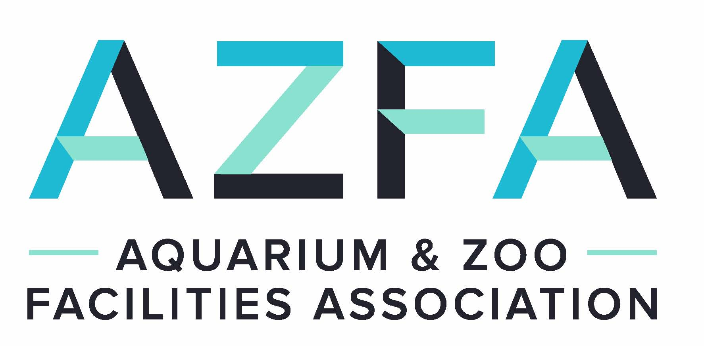
AZFA CONFERENCE
Denver, CO
October 9-13, 2022
Attendee Registration Form
Name: _______________________________________ Title: _________________________________
Institution: __________________________________________________________________________
Address: ___________________________________________________________________________
City: ________________________________________State:______________ Zip: ________________
Phone: ____________________Fax:________________ Email: _______________________________
Additional Attendee: _______________________________Title:_______________________________
Additional Attendee: _______________________________Title:_______________________________
(Please check all appropriate categories) Fee Amount
□ AZFA Professional Member, Active _____ x $275.00 _________
□ AZFA Professional Member, Retired _____ x $135.00 _________
□ AZFA Commercial Member (Full Conference) _____ x $515.00 _________
□ AZFA Commercial Member (Limited Conference) _____ x $400.00 _________
□ Additional Attendee (Icebreaker only) _____ x $125.00 _________
□ Additional Attendee (Zoo Day/Reception/Closing Banquet) _____ x $125.00 _________
Additional Activities
□ Pre-conference Top Golf _____ x $75.00 _________
□ Icebreaker Forney Transportation Museum 10/9 _____ x Included in registration fee
□ Post-conference tour Cheyenne Mountain Zoo 10/13 _____ x $ 50.00 _________
Meals (Please check all that you plan to attend)
___ Monday Lunch ___ Monday Reception ___ Tuesday Lunch ___ Wednesday Closing Banquet
Number of people in your party requesting vegetarian meals: _______________
Number of people in your party requesting vegan meals: _______________
Number of people in your party requesting gluten-free meals: _______________

Amount Enclosed: $_________________ (Make check Payable to Aquarium & Zoo Facilities Association) □ Check □ Credit Card □ Discover □ VISA □ MC Credit Card#:_________________________
Exp Date: ___________________________Signature: ___________________________
Is this your first AZFA conference? YES _____ NO _____
Will you be bringing a silent auction item? YES _____ NO _____
PLEASE SUBMIT YOUR REGISTRATION FORM BY AUGUST 31, 2022
Questions? Please contact Nikki Myers at (360) 832-7162 (office) or (360) 972-4536 (mobile) or Nikki.Myers@NWTrek.org.

