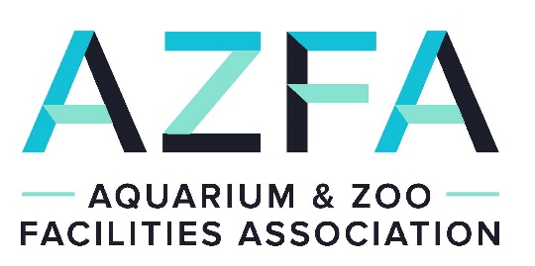

Clark Waldram Conservation Fund
Grant Application

Project Title: _______________________________________________
______________________________________________________________________________

Applicant’s Name: ______________________________________________________________

Institutional Affiliation: __________________________________________________________

Address: ______________________________________________________________________

______________________________________________________________________________

______________________________________________________________________________

Phone: ___________________ Fax: ____________________ E-mail: _____________________

Describe the specific conservation goal(s) of this project.

Is this project endorsed or supported by any other association? ______Yes ______ No

Amount requested: _________________

I have read and agree to abide by the terms outlined in the AZFA’s Clark Waldram Conservation Fund Guidelines. With my signature I understand that AZFA or AZFA Clark Waldram Conservation Fund dose not assume any responsibility for my program/project.

___________________________________________ ________________________
Signature Date

Project Narrative

Use the following format to describe the proposed project. Sections may be expanded but project narrative should not exceed two pages.

Purpose of the program/project:

Objective(s):

Project design/methods:

Schedule of completion:

Anticipated benefits/outcome:

Program/Project Budget:

[Provide a line item budget for the Program/Project]

AZFA Clark Waldram Conservation Fund Guidelines

Statement of Purpose:
AZFA conceived the Clark Waldram Conservation Fund in the spirit of conservation. The fund will be used for the support of local and worldwide conservation programs/projects, as AZFA’s Board of Directors deems appropriate.

Funding Eligibility:
To be eligible for funding, the applicant must demonstrate that the funds will be applied to construction materials, tools, equipment and technical expertise portions of the program or project and that the program or project has a conservation objective.

Application Procedure:
- Fill out the Clark Waldram Conservation Fund application form.
- Include any supporting information you deem appropriate.
- Applications submitted by January 1 will be considered at or before the Mid-year meeting, and those submitted by July 1 will be considered at or before the Annual meeting.
- E-mail applications and attachments to Enrique.Gaston@miamidade.gov (preferred) and cc: sam.peterson@sazo.org. Requesting a read receipt is recommended to be sure it was received.
- Submit written applications to:
The Clark Waldram Conservation Fund
c/o AZFA – Attn: Enrique Gaston
12400 SW 152nd Street
Miami, FL 33177

Conditions of Award Acceptance:
- The applicant will provide updates to AZFA on how the program/project is proceeding throughout the program/project from start to finish.
- The applicant will submit to AZFA a report outlining program/project results and use of funds for publication in The Outlet newsletter or AZFA website.
- If requested, a program/project report will be given at the AZFA annual conference.
- The AZFA’s Clark Waldram Conservation Fund will be acknowledged in publications/printed materials resulting from the program/project.
- All information given to AZFA will become the property of AZFA and will be used as deemed appropriate by the Board of AZFA.
- Information gained from the program/project will be made available to the public upon request.
- It is AZFA’s goal to achieve maximum conservation impact with limited funds. Therefore, awards must be applied toward the facilities related portions of the program/project.

Notes:
- Awards generally range from $100.00 to $1,500.00 but amounts can vary according to current AZFA budget, number of grant applications received, and evaluation of each proposal.
- Funding requests may be submitted for consideration year-round. Grants may be awarded as applications are received or biannually following the Mid-year and Annual Board meetings.
- Applicants will be notified of their award status within 30 days after approval by the Board.

